4. (25p) Answer all the questions on an electronic document.

Consider a matched filter ready for a Barker 7 (B-7) sequence having the following characteristics:

• chip pulse width: τc=1 μs (sequence length: 7 μs);

• samples per chip: N=40;

• B-7 magnitude: A=1 V

Then:

1. Make a plot of the magnitude (not the real component) of the matched filter output, in linear scale, for a B-5 sequence having the same characteristics than B-7 (A=1 V; τc=1 μs; N=40) having a SNR of 50 dB. Make comments about the relevant characteristics of the output signal from the filter.

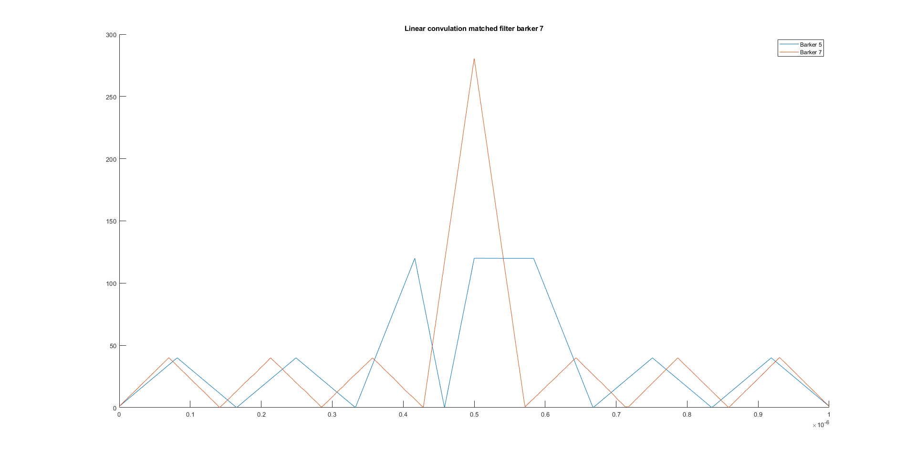

As we can see, due to the correlation between the matched filter barker 7 and the signal barker 5. The received signal is offset from the center and a peak voltage being more than twice as small as to barker 7 when in matched with the barker-7 filter on the output.

The sidelobes are no more symmetric and shows a clear sign of distortion.

1. Without making simulations, in case of a B-7 sequence (assume a noiseless scenario) incoming to the matched filter what would be the expected characteristics of the signal at the output of the filter in terms of PSLR (Peak to Side Lobe Ratio) and -3 dB pulse width?

In terms of PSLR, the expected result would be the same as the Peak power.

And the bandwidth would be B=1/τ where tau is the pulse width of 7 micro seconds.

BW =142847.15 Hz.